December 18th, 2010
Hi
This letter is written over the top of the corresponding letter for last year. It was interesting reading it as there are several things that are very similar. Read last year's latter (Dec 20th), which of course, you have saved!!
I had forgotten to mention it before, but there has been several arson attacks at the open-air stalls in the streets of Mong Kok, including Fa Yuen St and Sai Yeung Choi St. They took place very early one morning. The arsonist was caught on CCTV and was eventually arrested the other day. In the same vein, remember the acid-bomb attacks that have been happening recently? Well, the Causeway Bay acid thrower was caught and this past week was sentenced to 13 years in jail!
I have also mentioned that officials want to apply to host the 2023 Asian Games against a lot of opposition in the community. Well, they have decided to proceed even though there is a public consultation which is not yet over.
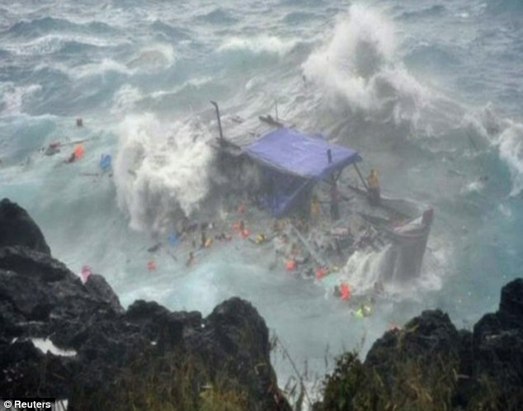
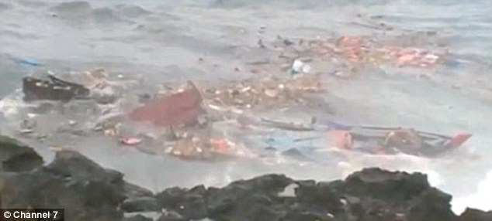
I suppose you heard, and perhaps saw, the asylum boat tragedy on Christmas the other day? Christmas Island is Australian territory far from Australia but very close to Indonesia. Because of this, boats, often unseaworthy crammed with refugees, set off seeking asylum in Australia. Well, a boat with refugees from Iran and Iraq was caught in a severe storm and dashed against rocks on the island, killing or drowning many on board. This was caught on video by locals, who did their best to rescue people in spite of the danger, and broadcast around the world. The site below shows pics of the tragedy:
http://www.dailymail.co.uk/news/article-1338730/Christmas-Island-shipwreck-27-refugees-die-rocks-tragedy.html

Gavin, I suppose you have seen something of the pipeline surfing championships? Some of it was broadcast on our local TV news. It is certainly an impressive sight and good to watch. I have been to the beach which has good pipelines but only in the summer when the waves are very small. The large waves only come in the winter when they build up unimpeded all the way from Alaska.
I mentioned last week that temperatures dropped a bit in HK. Well, they dropped substantially a few days ago and went down to -3°C at the top of Tai Mo Shan. However, they are creeping up again. My run yesterday also included Tai Mo Shan, from Tai Po to Sek Kong. Although cool - I kept my pullover on the whole time – there was no wind and the Sun was shining so it was OK. However, the run was very slow. At 2 h 51 min, it was 11 mins slower than last year, 18 min slower than my best, but not the slowest. It was not that tough; it was just slow. (The last leg, through the forest from Route TwiSK to Sek Kong, is the one where I had the massive spill a few years ago, injuring myself as well as spoiling your “Millennium Ball” cap. At one point, I passed lady going up Tai Mo Shan. In her backpack, she had an ice-axe!! I know temperatures had dropped, but I don't know what she was expecting.
Saw and heard on the news the other day, that the last flights for UK Harrier jets took place, mainly due to budget cuts. A pity; it was a great aircraft. Some pics here of final flights with more at the sites below.



Pics: http://news.bbc.co.uk/local/cambridgeshire/hi/people_and_places/newsid_9290000/9290056.stm
Pics plus a video including final 'bow' (literally, as in the photo above, which only a VTOL craft can do):
http://www.dailymail.co.uk/news/article-1338886/Harrier-jets-skies-final-farewell.html
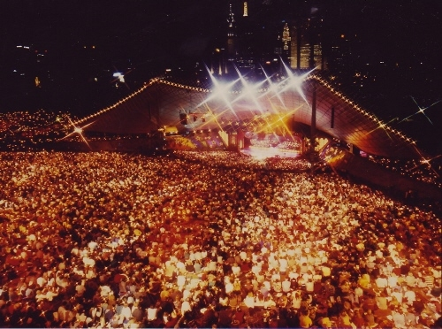
Last night, I watched a live broadcast of “Carols in the Domain” in Sydney in front of a record attendance of 100 000 people (or so the MC claimed). It was a very good show. Nadine – have you been to it? They include one or two 'stars' from overseas. This year, there was one from New York (Josh Groban – mean anything?).
Gavin, got your e-mail the other day on G-mail. It had been there for several days. As G-mail is not my main e-mail site, I don't often open it up. You mentioned that we are a part of the Order of Rechabites. Where did you here this? From Granddad, who was a member? I was never a member and knew almost nothing about it. It never featured much as I was growing up.
In HK, the ‘Nutcracker’, is being performed at the moment, as it is every Christmas time.
Recently I bought two cartons of potato chips from the supermarket. I had already finished one. Then the other day, I was about to open the second when a consumer report came on the TV news saying that in some foods, especially starches and cereals that are cooked at high temperatures, which includes potato chips and French fires, a carcinogen called acrylamide is present. I immediately put the carton back in the cupboard!! But I will probably eat the chips sometime.
I heard on the local news that you have been getting bad weather up in Boston. Exactly the same as in last year's letter. Still, that seems to be normal for this time of the year.
That’s about it for now.
Cheers

